MaineDOT Locally Coordinated Transit Plan Region 3
Cyr Bus Line
FY 2013 - 2017

Table of Contents

Description 1

Transit provider 1
Service … 1
Geographic area 1
Cyr Bus overview 1
How tickets and passes are sold and documented 2
Financial support 2
Cyr Bus passengers 2

Service by Route 2

Importance of Cyr Bus Line Bangor-Caribou Route to the Region and its Economy 3

Medical providers 3
Merchants and other vendors 3
Education 3

Accomplishments 4

Operations 4
Improved efficiencies 4

Service Gaps 4

Geographic coverage 4
Time of day/weekends 4
Clients 4
Service quality 4

Future Priorities, Potential Projects 4

Numeric Rating of Priorities and Projects 5
Percentage Rating of Priorities and Projects 5

Tables 6

Annual Report – Past Two Years 6
Capital Plan 7
Trips, Vehicle Miles, Past Two Fiscal Years 7
Revenues by Passenger Fare Category 7
Revenues and Expenses – Past Two Years 8
Budget for FY 2013, 2014 9
PTMS Vehicle Evaluation Summary Form FY 2013 10

JOHN T. CYR & SONS, INC
CYR BUS LINE

Description

Transit provider

Provider: John T. Cyr & Sons, Inc.
Contact person: Rebecca Cyr Whitmore
Address: 153 Gilman Falls Avenue, Old Town, Maine 04468
Telephone: 207-827-2335
Email: becky@cyrbustours.com
Website: www.cyrbustours.com

Service

Service area: Penobscot and Aroostook Counties
Type of service: Intercity

Geographic area

The Cyr Bus Line operates an intercity transit service between Bangor in Penobscot County, and Caribou in Aroostook County.

Cyr Bus overview

The Cyr Bus Line, owned by John T. Cyr & Sons, Inc., is a privately owned bus company headquartered on Gilman Falls Avenue in Old Town. The company provides a range of services throughout the northern part of the State, including the intercity service that operates between Bangor and Caribou. The Bangor-Caribou route includes one round trip daily between the two communities, 365 days per year. The Bangor to Caribou route provides connections to Greyhound at Dysart’s in Hermon and Concord Coach in Bangor.

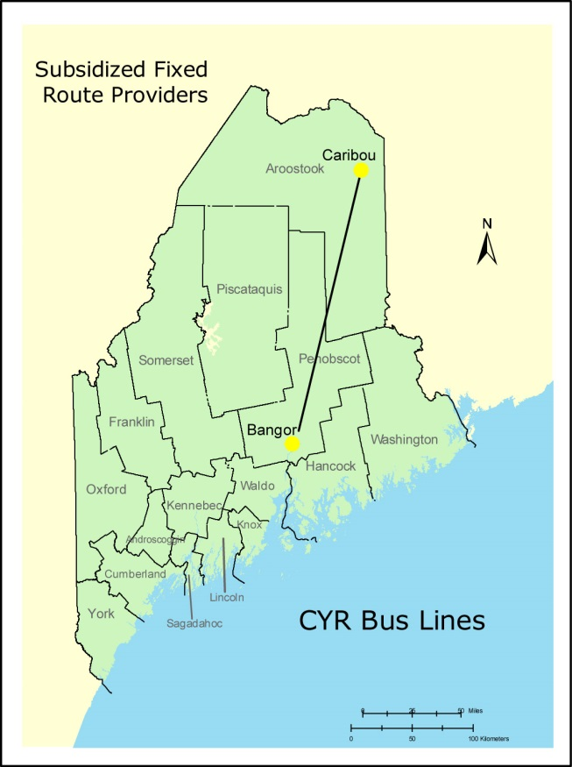

How tickets and passes are sold and documented

People riding the Bangor-Caribou service can purchase tickets from the driver, from one of the ticket agencies at the various bus stops or over the phone by credit card. The driver uses a tally sheet to keep track of the number of passengers. Ticket agencies receive a 10% commission.

Financial support

Financial support for the Bangor-Caribou route comes from the Federal Transit Administration, MaineDOT, fares and freight.

CYR Bus passengers

Most of the people who ride the Bangor-Caribou route are students and older people travelling between Northern Maine and the Bangor area. Cyr Bus does not keep a tally of the types of people riding the bus.

Service by Route
The importance of transit services cannot be measured simply by the number of trips.
Transit dependent individuals (including those with disabilities) require access to basic
services in addition to all of the benefits their communities offer.
The Bangor-Caribou route is the only route operated by Cyr Bus Line which receives a Section 5311 subsidy. The bus stops on this route include:

- Caribou, Fosters
- Presque Isle, On the Run
- Mars Hill, APEX
- Houlton, Circle K Big Stop
- Oakfield, Circle K
- Sherman, Circle K
- Medway, Irving
- Howland, The 95er
- Bangor, Concord Tailways
- Bangor, Greyhound
- Old Town, Cyr Bus Terminal

Importance of Cyr Bus Line Bangor-Caribou Route to the Region and its Economy

Public transit does more than ensure transit dependent individuals can move around their communities, and provide a safe alternative to using an automobile. The economy benefits on a variety of levels through residents and people visiting the community accessing local supermarkets, shopping centers, healthcare services and local neighborhood businesses.

The Bangor-Caribou route provides a vital economic link between Northern Maine and the Bangor area. Students attending the Job Corps Center in Limestone are an important beneficiary of the service, but so are people travelling from Aroostook County for medical and/or shopping services in the Bangor area.

- Medical providers

- Eastern Maine Healthcare, Lafayette Family Cancer Center, St. Joseph’s Hospital, the Maine Veteran’s Hospital, Bangor Health, and Community Services
- Physicians
- Mental health facilities
- Dental services
- Pharmacies

- Merchants and other vendors

- The Bangor Mall, Airport Mall, Brewer Shopping Plaza, Parkade Mall
- Supermarkets
- Downtown Bangor businesses
- Other business along the Bangor-Caribou route

- Education

- Loring Job Corps Center
- University of Maine
- New England School of Communication
- Husson College
- Eastern Maine Community College
- Beal College

Accomplishments

Operations

- Added Dysart’s as a ticket agent, bus stop, and connection to Greyhound
- CYR now has better equipment for serving people with disabilities
- Buses are washed every day

Improved efficiencies

- Newer, more efficient buses are used on the Bangor-Caribou route
- Cameras are installed on the buses

Service gaps

- Geographic coverage. There are no known gaps in geographical coverage.

- Time of day/weekends. Cyr Bus can make one round trip per day. There is no time, and ridership numbers are not high enough, to provide a second run.

- Clients. There are no known gaps.

- Service quality. There are no known service quality issues.

Future Priorities and Projects

The future priorities and projects shown below reflect future investments that were first identified by Cyr Bus Line and subsequently modified and prioritized by the public at a MaineDOT-sponsored Regional Transit Summit that was held at the Bangor Parks and Recreation Center in Bangor on November 12, 2013. Attendees were provided the opportunity to add a potential project or identify an issue for consideration at any time during the meeting.

In order to ensure maximum participation, MaineDOT sent an invitational letter, an agenda, and a list of potential priorities and projects to riders, social service agencies, healthcare facilities, chambers of commerce, private businesses, other transit operators in the region, members of the general public who had previously expressed an interest in transportation issues, and area legislators. Invitees unable to attend were afforded the opportunity to e-mail MaineDOT and make comments and recommendations both prior to, and following the meeting—these comments were included when compiling the ratings for each identified project.

A representative of MaineDOT provided an outline of the purpose and need for public input in this planning process to attendees and encouraged their full participation. A representative from each transit agency in attendance provided a brief history of their services and fielded questions from attendees. A facilitator presented the provider-identified future projects to the group and invited discussion which gave them with an opportunity to add to the list of potential projects. Attendees were provided with scoring sheets and rated each project. This process was repeated for each FTA/MaineDOT funded transit agency in the region.

The results of the Regional Transit Summit are reflected in two tables on the following pages. The first table shows the number of people who identified each of the priorities/projects as very important, somewhat important, not important, and no opinion. The second table shows the percentage ranking of the various priorities and projects in priority order.

NUMERICAL RATING OF PRIORITIES AND PROJECTS
Cyr Bus Line

Future Priorities and Potential Projects | Very  Important | Somewhat Important | Little Importance | No Opinion
A. Continue intercity service – between Northern Maine and Bangor area. | 8 | 2 | 0 | 0
B. Bus replacement– Replace buses about every two years | 5 | 4 | 0 | 1

PRIORITY RATING OF PRIORITIES AND PROJECTS
Cyr Bus Line

Future Priorities and Potential Projects | Very  Important to Somewhat Important | Little Importance to No Opinion
A. Continue intercity service – between Northern Maine and Bangor area. | 100% | --
B. Bus replacement– Replace buses about every two years | 90% | 10%

JOHN T. CYR & SONS, INC
Annual Report – Past Two Years

 |  | FY 2011 | FY 2012
Volunteer Resources
 | Volunteer Drivers
Vehicles
 | Number of Active Vehicles in Fleet | 1 | 1
 | Number of Inactive Vehicles in Fleet
 | Number of Spare Vehicles in Fleet | 1 | 1
 | Number of Vehicles Disposed
 | Number of Vehicles Sold
 | Number of ADA Accessible Vehicles | 2 | 2
Annual Operating Expenses
 | Annual Transit Operating Expenses | $419,880 | $430,732
 | Annual Social Services Operating Expenses
Annual Administrative Expenses
 | Annual Transit Administrative Expenses | Included above | Included above
 | Annual Social Services Administrative Expenses
Annual Operating Revenues
 | Fare Revenues | $299,088 | $320,519
 | Transit Contract Revenues
 | Social Service Contract Revenues
 | FTA-Federal Operating Assistance | $75,000 | $75,000
 | MaineDOT – State Operating Assistance
 | Local Operating Funds
 | Total Annual Operating Revenues | $374,088 | $395,519
FTA-Sources of Capital Funds
 | FTA-Federal Capital Assistance
 | MaineDOT-State Capital Assistance
 | Local Capital Funds
 | Total Capital Funds
Annual Miles
 | Annual Transit Miles (vehicle miles) | 146,000 | 146,000
 | Annual Social Service Miles (passenger miles)

 |  | FY 2011 | FY 2012
Annual Vehicle Hours
Annual Passenger Trips
 | Annual Transit Passenger Trips | 16,650 | 17,034
 | Annual Social Services Passenger Trips | 0 | 0
Safety
 | Fatalities | 0 | 0
 | Major Incidents | 0 | 0
 | Major Injuries | 0 | 0

JOHN T. CYR & SONS, INC
Capital Plan

Year | Project | Amount
2013 | Make “E-Line Run” tickets available on the website | $500
2015 | Have Wi-fi available on line run bus | $1,500

JOHN T. CYR & SONS, INC.
Trips, Vehicle Miles
Past Two Fiscal Years

ROUTE | One-Way Trips |  | Vehicle Miles
ROUTE | FY 2011 | FY 2012 | FY 2011 | FY 2012
Bangor-Caribou | 16,465 | 17,034 | 147,460 | 147,460
Total | 16,465 | 17,034 | 147,460 | 147,460

JOHN T. CYR & SONS, INC.
Revenues By Passenger Fare Category
Past Two Fiscal Years
Category | FY 2011 | FY 2012
Full Fare | $299,088 | $320,519
Total | $299,088 | $320,519

JOHN T. CYR & SONS, INC.
Revenues And Expenses – Past Two Years

 |  | FY 2011 | FY 2012
REVENUES
State (non-capital, administered by MaineDOT)
Other State (e.g. Maine Department of Labor)
FTA:
 | 5307 (small urban area systems)
 | 5309 (capital assistance)
 | 5310 (elderly, disabled)
 | 5311 (rural area systems) | $75,000 | $75,000
 | 5316 (job access, reverse commute)
 | 5317 (new freedom)
Passes
Fares |  | $299,088 | $320,519
Advertising
Contract Revenue
Community Support
Other
MaineCare
TOTAL |  | $374,088 | $395,519
EXPENSES
Utilities |  | $2,645 | $15,737
Insurance |  | 10,650 | 11,100
Accounting, Auditing, Legal |  | 47,250 | 45,000
Vehicle, Fuel And Oil |  | 106,675 | 112,625
Parts And Tools |  | 5,375 | 6,185
Salaries And Fringe Benefits |  | 98,300 | 94,000
Rent |  | 3,600 | 3,600
Advertising |  | 5,465 | 6,225
Vehicle Maintenance |  | 20,840 | 25,200
Taxes And Registration |  | 8,250 | 9,000
Supplies |  | 1,500 | 1,500
Other (Dep. Rooms, Meals) |  | 99,330 | 100,560
TOTAL |  | $419,880 | $430,732

JOHN T. CYR & SONS, INC.
Budget FY 2013 and FY 2014

 | FY 2013 | FY 2014
REVENUES
FTA (non-capital, administered by MaineDOT) | $75,000 | $75,000
Fares | $327,000 | $335,000
TOTAL | $402,000 | $410,000
EXPENSES
Utilities | $16,000 | $16,500
Insurance | $11,700 | $12,500
Accounting, Auditing, Legal | $38,000 | $40,000
Vehicle, Fuel And Oil | $118,000 | $121,000
Parts And Tools | $7,000 | $7,500
Salaries (Drivers) | $102,000 | $108,000
Salaries (Office) | $9,500 | $10,000
Rent | $3,600 | $3,600
Advertising | $6,500 | $7,000
Vehicle Maintenance | $30,000 | $35,000
Taxes And Registration | $9,750 | $10,500
Supplies | $1,500 | $1,500
Other (Dep. Rooms, Meals) | $102,000 | $105,000
TOTAL | $455,550 | $478,100

PTMS VEHICLE EVALUATION SUMMARY FORM FY 2013
JOHN T. CYR & SONS, INC.

1 | VIN | 3CET2M62XA51 | 2M93JMHA58W
2 | Fleet # and Status* | #1040 A | #930 SP
3 | Vehicle Type ** | SHDB | SHDB
4 | Make, Model | VOLVO 9700 | MCI 54
5 | Year | 2010 | 2008
6 | Fuel Type | DIESEL | DIESEL
7 | Fuel Use – 12 months | 48065 | 77023
8 | Mileage | 288387 | 462136
9 | 12-month Mileage | 104064 | 43396
10 | Repair Cost - 12 months | 17500 | 7700
11 | Repair frequency - 12 months*** | 3 | 2
12 | Vehicle appearance - interior | GOOD | GOOD
 | Vehicle appearance - exterior | GOOD | GOOD
13 | ADA Accessibility: | YES | YES
 | Equipped/Working | YES | YES
 | Tie Down | YES | YES
 | Announcement System | YES | YES
 | Signage and Stops | NO | NO
14 | Passenger Amenities
 | Air Conditioning | YES | YES
 | Working Heater | YES | YES
 | Tinted Windows | YES | YES
 | Padded Seats | YES | YES
15 | Type of fare collection system | PRE-PAID | PRE-PAID
16 | Date of Inspection | 8/12/12 | 1/13/12
17 | Inspector's Name: | STEVE MILES | STEVE MILES
* A (Active); I (Inactive); SP (Spare); D (Disposed); Sold (Sold)
** SHDB (Standard Heavy Duty Bus); MHDB (Medium Heavy Duty Bus); SMDB (Small Medium Duty Bus); LDB (Light Duty Bus); V (Van).
*** Repair Frequency: (1) – Routine Preventive Maintenance; (2) Minor Repairs (vehicle not taken out of service); (3) Major Repairs

